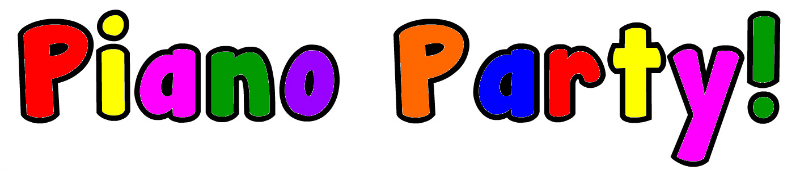Registration 2018-19

How did you hear about Piano Party!:

Name of Student:
Name of Caregiver/Adult accompanying student:
Day/Time/Location of private lesson or class:

Student Age/Birth-date:
Name of Pre-School (if applicable):
Experience with Music Lessons:
Dietary Restrictions/Allergies:

Parent(s) Name:
Home Address:
Contact Number:
Email Address:
Is there a piano/keyboard in your home? If so, describe:
I give permission for my/my child's picture to be on: (underline) Studio Website, Facebook, Youtube
____ (check please) I have read The Music Studio Policies and submitted the Enrollment Agreement.
Thank you for joining the music-making family at The Lark’s Nest Music Studio!
With gratitude, Carol
VisitTheLarksNest.com (206) 552 0876 visitthelarksnest@gmail.com

