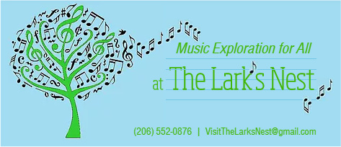

Adult Student Registration 2018-19

How did you hear about The Lark's Nest Music Studio?

Name of Student:
Day/Time of Lesson:
Instrument: (underline) Piano, Organ, Voice, Recorder, Other - ____________________

Student Age/Birth-date:
Education/Occupation:
Experience with Music Lessons:
Dietary Restrictions/Allergies:

Home Address:
Contact Number:
Email Address:

Is there a piano/keyboard/instrument of choice in your home? If so, describe:
I give permission for my picture to be on: (underline) Studio Website, Facebook, Youtube
____ (check please) I have read The Lark’s Nest Music Studio Policies and submitted the signed Enrollment Agreement.

Thank you for joining the music-making family at The Lark’s Nest Music Studio!
With gratitude, Carol

VisitTheLarksNest.com (206) 552 0876 visitthelarksnest@gmail.com

